[PHOTO CAPTION] Image of Santa Rafqa generated by Master Max AI. Copyright St Saviour’s Church, Lewisham, 2025
[INTRO] Some people suffer and suffering defeats them. Others? Well, they rise above it. Nelson Mandela, in a letter to his wife Winnie from Kroonstad Prison in 1975 wrote: “"The greatest glory in living lies not in never falling, but in rising every time we fall." Saint Rafqa (sometimes called Saint Rebecca) is the epitome of Mandela’s quote; someone who, in the face of seeming insurmountable odds, just kept on trying. Not only that, but she also called suffering upon herself, in order to be closer to God and honour the Passion of the Christ.
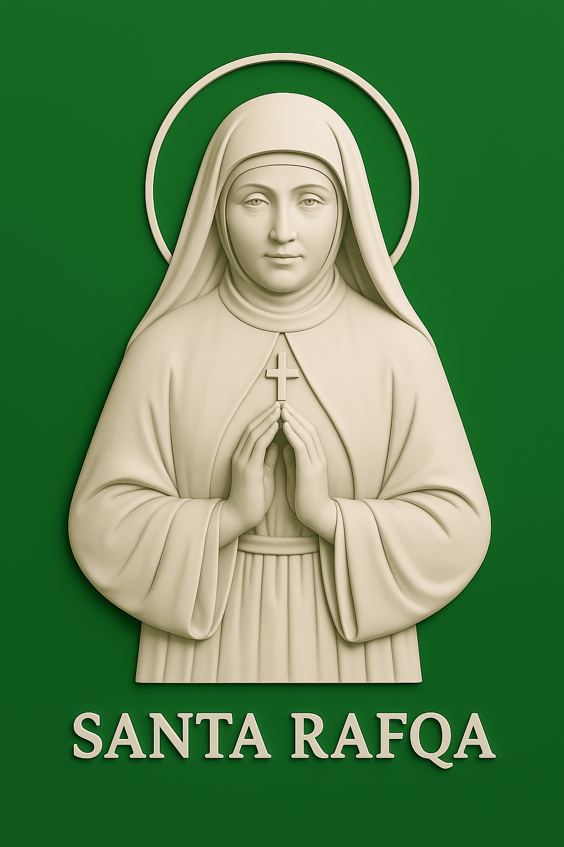
[Title] Santa Rafqa: Faith As Self-Sacrifice
Rafqa Pietra Chobok (1832-1914) was a Lebanese Maronite nun, renowned for her deep devotion to God, and her unwavering faith in the face of adversity and personal suffering. She endured blindness, paralysis, and intense pain, which in faith, she offered as a sacrifice to God and is revered for her particular brand of piety. A growing number of miracles are attributed to her intercession. Santa Rafqa was canonised by Pope St John Paul II in June 2001 and is the patron saint of lost parents and the sick.
A life of service
Rafqa was born in Himlaya, a Lebanese village located in the Matn District in Mount Lebanon, on June 29, 1832, the only child of Saber Mourad El Rayess and Rafqa Gemaye, and was given the name Boutrossieh. Her mother died when she was seven and at the age of nine, she was sent to work as a servant for four years in Damascus, when her father fell on hard times. She returned home in 1847 to find that her father had remarried.
When Boutrossieh was 14 years old, her stepmother pressured her to marry her brother, while her maternal aunt wanted her to marry her son. Boutrossieh had no interest in either, which caused discord in her family. Asking God to help her, she opted to become a nun, leaving home unannounced, to the Convent of Our Lady of Liberation at Bikfaya. Her family tried to persuade her to return home. She strenuously objected to returning, leaving her family to leave empty handed, and she never saw them again.
Some years later a relative, Joseph Gemayel, founded a religious institute for women that offered them a full time education and religious teaching. Boutrossieh was among the first candidates, known as the Daughters of Mary of the Immaculate Conception (shortened to the Mariamette Sisters), to join. She was 21.
In 1860 she was sent to the Jesuit mission at Deir-el-Qamar, in Mount Lebanon. It was a testing assignment. A local conflict over land rights between Druze landowners and Maronite farmers, coupled with resentment of Ottoman land reforms and growing European influence in the country, created a volatile environment, which ignited the conflict into civil war. In less than two months the Druze killed over 7500 people, destroying some 360 villages, 560 churches, 28 schools, and 42 convents. Sister Rafqa, deeply affected by the massacres, managed to save a child’s live, hiding him from soldiers in the skirts of her habit. She received the habit of her congregation the following year and took her first, temporary vows in 1862, taking the name Rafqa. Sent to a Jesuit school in Ghazir, she stayed for several years, teaching religious instruction to workers in a local cotton mill, and studied Arabic, calligraphy and mathematics.
In 1871, when the Mariamette Sisters merged with another institution to form the Order of the Sacred Hearts of Mary and Jesus, Sister Boutrossieh opted instead to join the monastic Baladita Order, after a dream in which, among others Saint George encouraged her to serve as a cloistered nun. The same year she joined the Monastery of St. Simon in Al-Qarn, where she took her final vows and took the name Rafqa, remaining in the monastery until 1897.
Some years earlier, in 1885, Sister Rafqa began to lose her sight, which she offered up in selfless sacrifice to God. following a botched operation to restore her sight, she lost an eye and suffered intense headaches, which she offered up in commemoration of the Passion of Christ. Nevertheless, she remained an active member of her community, spinning wool and cotton, knitting and of course, prayer.
Monastery of St. Joseph
In 1897, the Lebanese Maronite Order constructed a new monastery dedicated to St. Joseph at al Dahr in Jrabta, Batroun province. Rafqa was one of six nuns, led by Mother Ursula Doumit, who were sent there to set up a working convent. By 1899 she was completely blind and paralysed. By now confined to bed, Sister Rafqa used her time to knit socks. Near the end of her life, she was asked by Sister Ursula if she would like to see; Rafqa prayed to be able to see for an hour, and reportedly this prayer was answered. Sister Rafqa dies on March 23rd, 1914.
On March 23, 1914, she died. Her body was buried in the monastery cemetery and was later transferred to the monastery chapel.
Beatification and canonization
On June 9, 1984, on the vigil of Pentecost, Pope Saint John Paul II, approved the miracle of Elizabeth Ennakl, who was said to have been completely cured of uterine cancer in 1938 at the tomb of Sister Rafqa. In November 1985, the pope declared Sister Rafqa as a Blessed, and on June 10, 2001, he proclaimed her sainthood. Her feast day is celebrated on March 23rd.
Conclusion
Sister Rafqa prayed to share in the sufferings of Christ, and her prayer was answered with severe headaches, blindness, and paralysis. She endured these afflictions for many years, experiencing intense pain and physical deterioration, and she embraced these trials with joy and patience. Her story is an inspiration to those who suffer, demonstrating the power of faith and love in the face of adversity.

